THEME: LIVING THINGS (ANIMALS IN OUR DIVISION)
SUB – THEME: Types of living things
New words
Insects, animals, birds, plants, domestic, wild
What are living things?
Living things are things which have life
Livingthings are divided into two groups namely;

- plants
- Animals

- Types of living things
e.g. insects, animals, birds, fish
Examples of insects
cockroaches, houseflies, bedbugs, mosquitoes etc
Examples of birds
Pigeon, fish eagle, chicken, guinea fowl, ducks
Examples or types of fish
Tilapia, Nile perch, shark, Electric fish etc
Examples of animals
Evaluation exercise
  - What are livingthings?
  - Write True or False
a) Living things are things which have life._______________
b) An insect does not reproduce. ________________
c) A person respires.________________
d) A table responds to stimulus. _________________
  - Circle the main groups of living things
Amphibians, Plants, birds, fish, Fungi, Insects, Animals
4. Underline the odd man out.
Dog, table, donkey, people, snail, lizard, icon.
5. Write two characteristics of non-living things
6. A _______________ is a living thing. (got, goat)
SUB – THEME: Characteristics of living things and types of animals
New words
grow, reproduce, grow, breathe, feed, domesticated, locomote
Characteristics

- They grow
- They reproduce
- They breathe
- They eat/feed to live
- They move

Classes of animals
- Animals are grouped in six major classes. These are mammals, birds, fish, insects, reptiles and amphibians
- animals in air e.g. birds, bats
- animals in water e.g. fish, crocodiles
- animals on land cows, zebras, elephants etc
Types of animals

- Domestic animals
- domesticated animals
- wild animals

Domestic animals are animals kept at home
Examples of domestic animals cows, goats, sheep, rabbits
Wild animals are animals that live in the bush/forests.
Example
zebras, lions, hyenas, giraffes.
Some wild animals like monkeys can be tamed to live in people’s homes
These animals are called domesticated animals.
Evaluation Exercise
Write True or False
- Domestic animals are animals which live on their own in forests or bushes.______________
- A parrot is kept as a pet. __________________
- Wild animals are found in the zoo.__________________
- Write two examples of domesticated animals.
- Write down four examples of wild animals.
- Draw and name any two domestic animals.
SUB – THEME: Uses of domestic animals
- Pigs give us pork and sheep give us mutton.
- They also provide us with skins and horns.
- Sheep provides us with wool.
- Dogs are used for protection.
- Cats help to chase a way rats.
- Some animals are sold to get money.
- Cows and goats can be used to pay bride price.
- Oxen are used for ploughing.
- Cow dung got from animals can be used as manure in our gardens.
- Cow dung is smeared on the floor and walls of houses.
- Drums are also made from skins and hides.
- Bags, skins and hides.
- Some animals provide transport.
Dangers of wild animals
- Some wild animals eat people e.g. lion
- Some wild animals destroy crops.
- Some wild animals can eat domestic animals
Evaluation exercise
- Name the animals from which we get the following products.
- Wool - _______________ c) milk - _______________
- Eggs- _______________ d) fur- ________________
- Underline the animals which guard us at home
Lion, donkey, dog, fox, cat, tiger
3. Which of these is made from animal skin?
mattress bag book door
4. Give two animals which live in water
5. Home of a cow____________________(den,byre,kraal)
6. Oxen are used for ________________________. (digging, transport, ploughing)

SUB – THEME: Animals and their homes (habitats)
New words
shed, habitat, kraal, earthworms, den, nest, garden, sty
Homes (habitats) of domestic animals
Peoples’homes
- pig – sty/pen
- cattle – shed/kraal
- dog – den/kennel/home
Homes (habitats) of wild animals
- Forests, burrow (underground), nests, water, bushes
- Animals that are found in the school compound include cats, rabbits, cows, lizard
- Animals found in gardens e.g. monkeys, different types of birds , earthworms, rats, squirrels, tortoise
Reasons why animals move from one place to another

- To get food
- To get water
- For protection
- For shelter
- To mate
- To look for their young ones
- To look for company

Ways of how different animals move
Movement | Animals
Crawling | Lizards, chameleon, tortoise
Hopping | Frogs, grasshopper, locust, toads
Flying | Butterflies, houseflies, bees
Walking | Cow, dogs, hens, man
Gliding | Snail, slug, snake
Wriggling | Caterpillar, earthworms, maggot
Swimming | Fish, ducks, swans, geese

Importance of animals to plants
- Animals provide manure to plants to grow well.

Evaluation Exercise
- _______________ is a home of a living thing. ( habit, habitat, Habitant)
- Mention any two homes of domestic animals.
- Underline animals which can move by swimming.
Man, fish, crocodile, snake, octopus, duck, whale, turtle
- Mention two dangers of wild animals?
6.Match the animals below to the way they move
Animal Way of movement
snake walking
elephant flying
bee crawling
grasshopper gliding
chameleon hopping
i) snake ___________________________
ii) elephant ___________________________
iii) bee ___________________________
iv) fish ___________________________
7. I am kept at home. I have four legs. I eat both meat and bones. I protect the home of my master. Who am I?

SUB – THEME: FISH
Animals in swamps and water e.g. birds, crested crane, fish, toads, monkeys, snakes.
- Some animals live permanently in water as their habitat e.g. crocodiles, fish and hippopotamus
- Some animals live in ponds of water
An aquarium is a tank in which fish and other water creatures are kept.

Parts of a fish
e.g. nostril, fins, scales eyes, gill
7 8 1 2 3

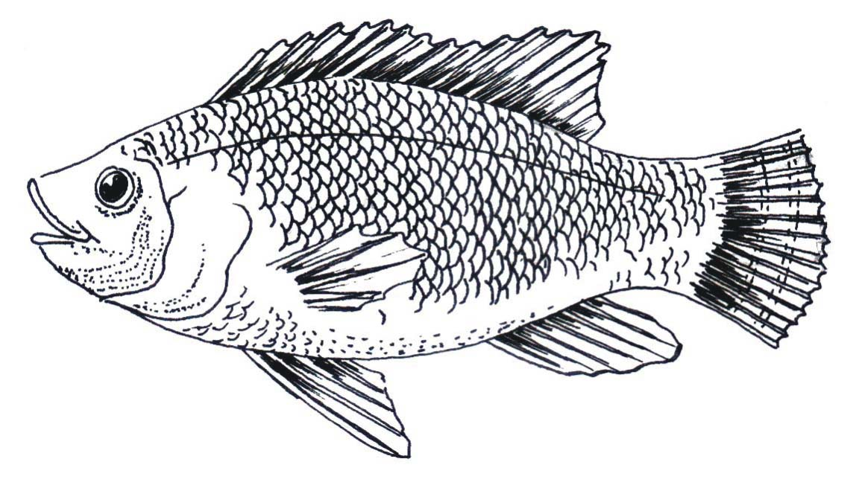
6 5 4
Uses of each part
- Nostril is used for smelling food
- Eyes are used for seeing
- Dorsal fin is for protection
- Lateral line is used for sensing sound waves in water to hear if there is danger.
- Tail, fin is used for steering and making corners.
- Scales are used for protection
- Pectoral and pelvic fins are used for reducing speed and going up or down wards in water.
- Gill cover protects the gills inside.
- Gills are used for breathing.
- Mouth is used for getting food.
Evaluation Exercise
- Give three types of fish
- Write one characteristic of a fish
- Use the following words to complete the following sentences
Lateral line, gills, nostril, aquarium dorsal fin, scales
- __________________ is used to smell food.
- Lungs are to man as __________ is to fish.
- _______________ detects sound waves in in water in case of danger.
- Puppy is to dog as______________ is to fish.
- The fish uses ________________ for protection.
- A man-made pond for keeping fish and other creatures is called___________________.
Uses of a fish
- Source of food (protein)
- Scales are used to make bags and belts
- fish helps to control mosquitoes larva
- Fish bones help in making of glue
- Fish is used in manufacture of animal feeds
- Some people get jobs e.g. fish mongers
Methods of catching fish
By use of
- Fishing hooks
- Fishing nets
- Fishing baskets
Fish preservation
Fish preservation is the way of keeping fish for a long time without going bad.
How we preserve fish?
- By smoking
- By salting
- By sun drying
- By freezing/refrigerating
- By canning/tinning
Activity
Write True or False
1. Fishmongers sell fish as a job.___________________
2. Fish feed on the larva of mosquitoes. ______________
3. Freezing/refrigerating can keep fish for a long time without going bad._______________
4. Fish is a source of carbohydrates.___________________
5. The organs which help a fish to swim are sharp.__________________
Answer questions in full sentences
6. What does a fish use for breathing?
7. How does a fish help in the control of malaria?
8. What is an aquarium?
SUB – THEME: Birds and insects
Domestic birds include: - hens, turkeys, ducks, pigeons
- Wild birds e.g.
crows kite, weaverbirds, eagle
sparrow, crested crane and guinea fowls.
The crested crane is the most beautiful and graceful bird in Uganda.
- It is Uganda’s national emblem.
Birds like parrots and peacocks are kept at home as pets.
- Some birds eat insects like grass hoppers which destroy our crops.
- Some birds give us meat and eggs.
The Bat flies, has no feathers and does not lay eggs. It produces its young ones a live.
Characteristics of birds

- They have beaks
- They lay eggs
- They have two wings and two legs
- They have feathers
- Some birds fly

Habitats for birds
Some birds live in nests, homes, burrows, in gardens, in swamps etc
Evaluation exercise
1. In one group of birds we have; emu, ostrich, penguin and peacock. How are these birds different from other birds in the way they move?
2. Circle the odd man out
Duck, ostrich, hen, emu, pigeon, eagle.
3. How can domestic birds be a source of income?
4. Name the bird found in the middle of the Ugandan National flag.
5. Underline two birds that are kept at home as pets
Penguin, Pigeon, Kingfisher, Parrot, Peacock

6. What covers the body of a bird?
7. Mention any four examples of domestic birds
SUB – THEME: Care of birds
Caring for domestic birds
- Protecting nests, protecting eggs, treating birds
- Cleaning habitats
- Protecting birds (painting, keeping in doors)
- keeping bird records
- Participating in grooming
- feeding them
Care for wild birds
- Protection from hunters
- Discouraging bush burning
- Avoid destroying forests and swamp
- Provide food, protection and medication.
- Avoid unnecessary killings (poaching and hunting)
Evaluation exercise
1. How do birds reproduce?
2. Give one use of feathers to birds.
3. Why do farmers keep birds?
4. Put a tick on ways of caring for birds.
a) Allow poachers to take care for them.
b) Provide food, protection and medication
c) Discourage the veterinary officer to treat them when they are sick.
5. Give two reasons why we need to care for wild birds.
(i)_____________________ (ii)______________________________
SUB - THEME: Insects
Insects are small animals with six legs and usually have pairs of wings
Examples of insects are: Grasshoppers ants, termites, bees, wasps, butterfly

Characteristics of insects
- Some move in groups (e.g. bees, black ants)
- Some bite (e.g. red ants)
- Some have wings (e.g. locusts, butterflies)
- Some do not have wings (e.g. caterpillars)
- Some have six legs (e.g. wasps, bees)
A spider is not an insect because it has eight legs.
Habitats for insects: insects live in anthills, in soil and plants
Parts of an insect
Head, eyes, thorax, legs, abdomen, feelers, legs spiracles, eyes, proboscis, wings, ovipositor

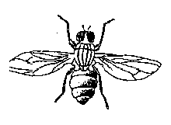
What are social insects?
Social insects are the insects that live, move and work together. For example bees, red ants, termites, wasps, black ants
Solitary insects are insects which do not live, move and work together for example Houseflies, locusts, mosquitoes, cockroaches, dragon flies, and butterflies.
Types of bees
- Worker bees
- Drone bees
- The queen
Uses of bees to man
- Bees provide honey
- Bees provide bee wax
- Young bees are eaten
Products got from bee wax

- candles
- shoe polish
- after shave
- crayons

Caring for bees
- provide a hive
- provides water
- plant flowers for nectar
- Provide something sweet when introducing a hive.
Evaluation Exercise
- Learners draw and fill in the parts of an insect.
- Why is a spider not an insect?
- Bees, wasps, termites and red ants live and work together. What general name do we give such insects?
- Give one example of harmful insects.
5. Underline the correct stage in the life cycle of a butterfly.
Lava lover larva lervae
6. Which of these insects does not belong to the group?
Grasshopper housefly white ant
7. Apart from the queen bee name any other bee found in a hive.
8. Mention two products made from beeswax
9. State one use of insects to people.

THEME: LIVING THINGS (Plants in our division)
SUB – THEME: Plants and their habitats
Examples of plants
e.g. maize, yams, sisal, cactus, cassava, hibiscus plant.
Characteristics of plants
- They grow
- They feed
- They reproduce
- They respire
Plant habitats
Plants have different habitats e.g.
- Some plants grow in water and wetlands like: the papyrus reeds (ebitoogo), the cabbage the water hyacinth and water lily.
- The water hyacinth is dangerous because it finishes all the oxygen in the water therefore it makes it difficult for the fish to breathe.
- These water plants grow well in water or wetlands and can die easily when the wetlands dry up.
Evaluation exercise
- Mention any two habitats for plants.
2. Underline the correct spelling of the parts of a plant below.
(a) lives leeves leaves levees
(b) flute fluit fruit fruite
(c) sterm stem stemu stern
(d) routes rots rutes roots
3. Of what importance are papyrus reeds in wetlands?
4. State any two characteristics of plants.
5. How dangerous is the water hyacinth?

SUB – THEME: Plants and their habitats
Some plants grow in the school garden. They are grown by people for food e.g.
- Vegetables, crops like cabbages, dodo, nakati, jobyo, lettuce and spinach.
- Fruit crops like mangoes, tomatoes, guavas, oranges, passion fruits.
- Root crops like potatoes, cassava and carrots.
- Cereal crops like maize, rice sorghum, wheat etc.
- Leguminous crops like beans, peas, Soya beans, groundnuts etc.
- They are green and therefore make their own food.
Some plants grow well in different soils
- Rice and some vegetable plants grow well in dry sandy soils that is why they are common in deserts.
- Banana plants, beans, peas, maize, fruits, trees, vegetables and many other plants grow well in loam soils.
Evaluation exercise
- Write down four examples of plants we can find in a school garden.
2. Underline the odd man out from the lists below.
(i) groundnuts beans cassava peas soya beans
(ii) mangoes oranges yams guavas lemons
- Use the words in the brackets to suit the group of crops given.
(Cereals,Vegetables,Rootcops,Fruits,Legumes
- Nakati, Dodo, Cabbages, Tomatoes _________________
- Carrots, Cassava, Sweet potatoes________________
- Beans, Peas, Soya beans,Groundnuts________________
- D) Pineapples, Oranges, Pawpaw,Passionfruits.________________
- Give one example of a crop that can grow in dry sandy soils.

SUB - THEME: Parts of a flowering plant and their uses
Flowering plants are plants which bear flowers while non – flowering plants are plants which don’t bear flowers.
Parts of a flowering plant are roots, stem, leaves, flowers, seeds.
- Examples of flowering plants include: maize, sunflower, beans, simsim, peas, avocado, millet, orange, tomatoes, guava, groundnuts, coffee, rice, cotton
- Some non flowering plants include mosses, pines, cypress ferns and liverworts
Drawing of a flowering plant
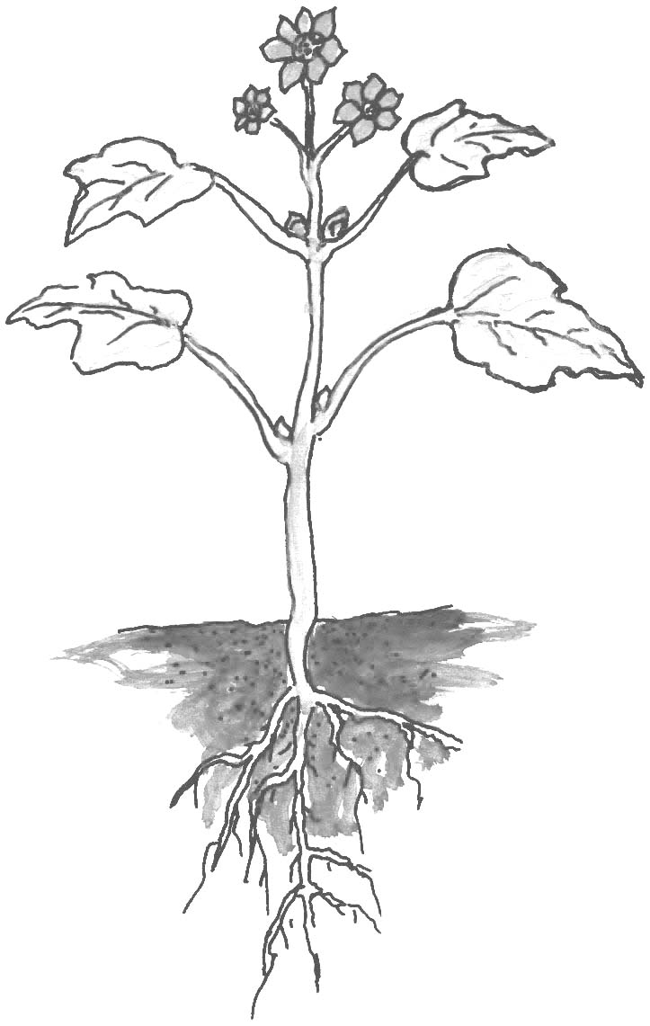
Evaluation exercise
Draw the flowering plant and label parts marked
SUB – THEME: Parts of a flowering plant and their uses.
A flowering plant is divided into two main systems and three major parts.
- The two main systems are: -
- the roots system
- The shoot system
- The three major parts are:

- The roots
- The leaves
- The stem

The root system consists of the following parts namely
- the main root or tap root, the fibrous roots, root hairs, root cap and lateral roots
- The shoot system consist of the following parts namely:
The leaves, stem, terminal bud and axillary bud and flowers.
SUB – THEME: Leaves
Parts of a leaf
K
O
M
P
N
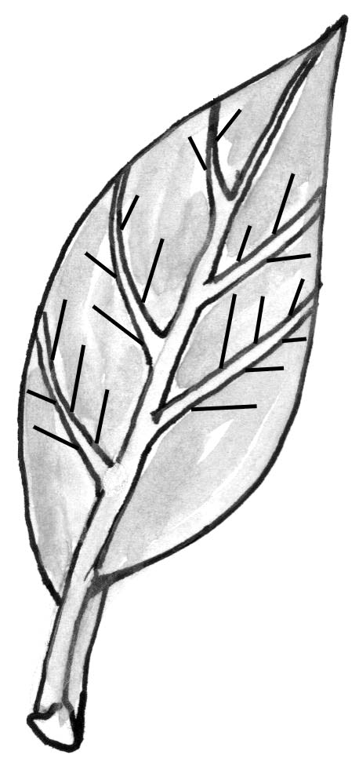
L

There are two main types of leaves namely:
- simple leaves
- compound leaves
- A simple leaf is one with one leaf blade and one leaf stalk.
- A compound leaf is one with many leaflets on one leaf.

Examples
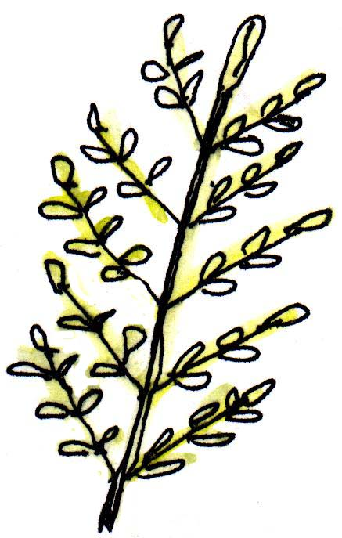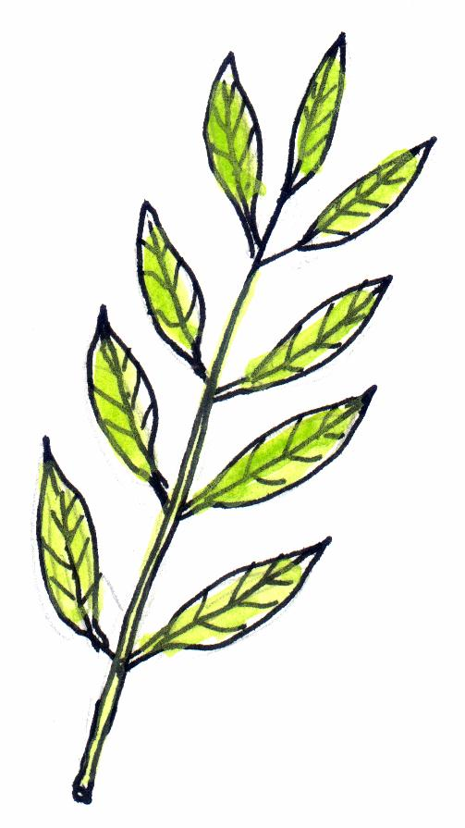
simple leaf compound leaf compound leaf

Functions of leaves to a plant
- Leaves make food for the plant called starch.
- leaves allow the plant to breathe in oxygen through holes called stomata.
- leaves carry on transpiration
- Some leaves store food and water like the onions.
The process by which green plants make their food in the presence of sunlight is called photosynthesis.
- Photo means light while synthesis means making
The requirements necessary for photosynthesis to take place are
- Chlorophyll that traps sunlight
- water
- carbondioxide, it is found in air in the space
- sunlight, it provides light energy needed for the process.
Conditions
- chlorophyll
- sunlight

Materials
- carbon dioxide
- water
Uses of leaves to people
- May leaves are eaten as green vegetables, e.g. dodo, cabbage, nakati, lettuce, spinach and beans.
- Some leaves are used as local medicine e.g. omululuza cures malaria.
- Many leaves are eaten by both domestic and wild animals.
- Some leaves are used in thatching houses e.g. spear grass.
Evaluation exercise
1. Write True or False in the gaps
(a) A seeding is a non-living thing. ____________________
(b) Plants and animals need food to grow. ________________
(c) Chlorophyll is the colouring matter in plants. ________________
(d) All plants produce flowers. __________________
2. Name the type of leaf shown below.
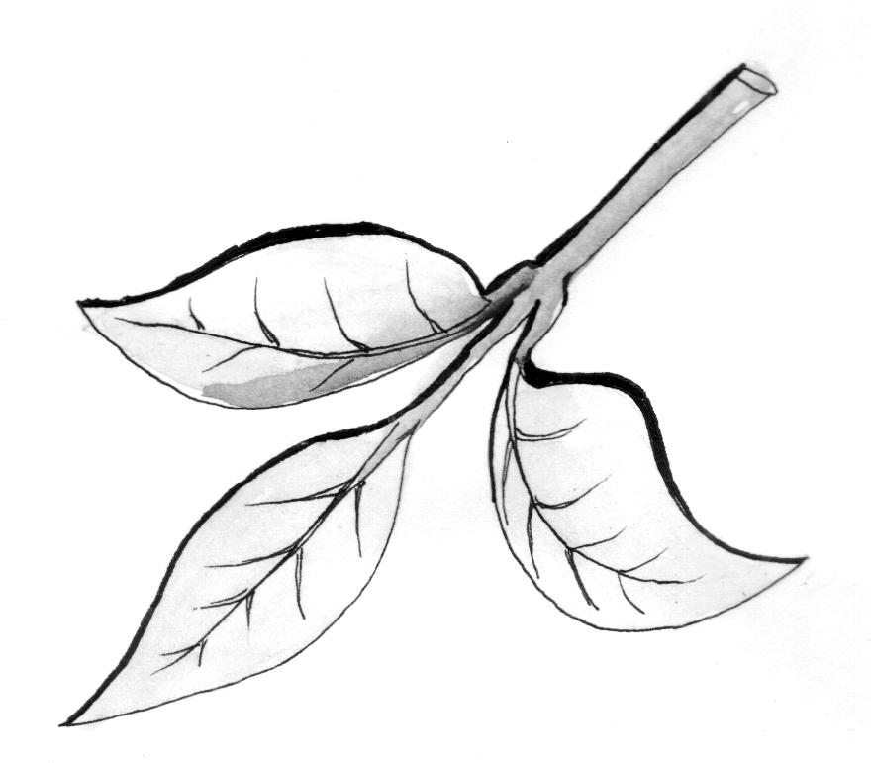
3. Write down functions of leaves to a plant.
4. Fill in a correct word from the box to complete the sentences.

Carbondioxide plants both process

Photosynthesis is a __________________ in which plants make food. Plants need _____________________ to make their food. Animals get _________________ oxygen and food from plants.
5. What do the words mean?

- photo
- synthesis

6. Name the conditions necessary for plants to make their food.
7. Write down any two uses of leaves to people.

SUB – THEME: STEMS
Types of stems
There are three types of stems namely

- upright stems or Erect stems
- underground stems
- climbing stems

- Upright stems
These are stems found on the tree and other plants which grow upright e.g. Muvule, mahogany, maize, beans, millet, rice, coffee, pineapples
- Underground stems:
These are stems which grow underground. They are found in the soil
Examples include: - onions, ginger, Irish potatoes, yams
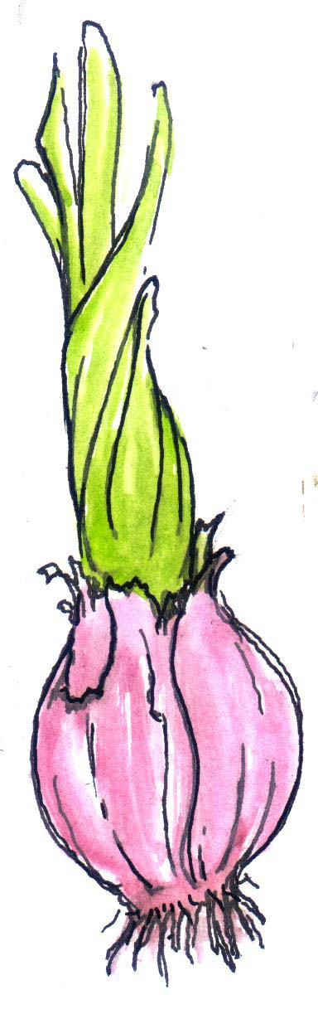
Functions of stems to a plant
- They hold the leaves in order to get sunlight
- They hold flowers and fruits
- They take water to the leaves from roots
- Some stems store food for the plants
Evaluation exercise
  - State any three functions of the stems to plants.
  - What name is given to the highest growing tip of a plant?
3. List A has crops; List B has the parts that we eat on plants. Match the crop in list A with the part which we eat in list B
List A List B
Cassava stem
Banana leaves
Sugarcane roots
Onion fruits
Mushroom

4. Write down two plants which have upright stems.
5. Name three plants which have underground stems.

Climbing stems
These are stems which are weak and cannot support themselves upright.
They climb other plants in order to get sunlight.
There are three ways in which they climb others
- using tendrils
- using hooks
- by twining or clasping
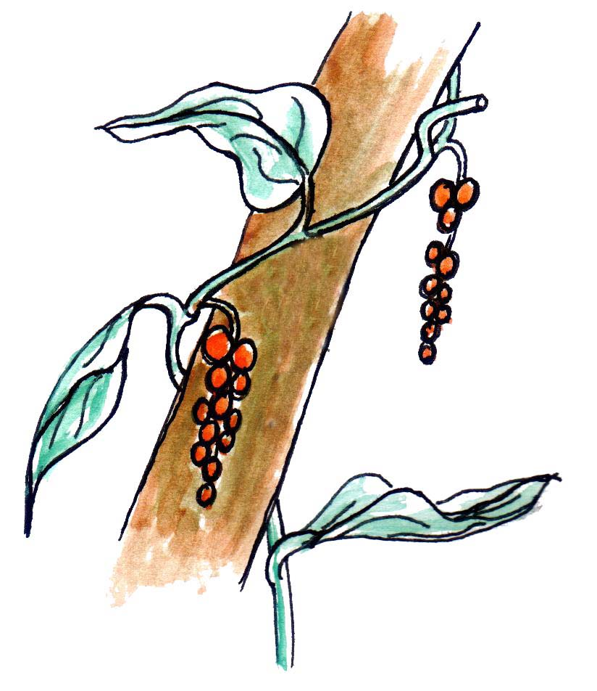
Clasping or Twining
Uses of stems to people
- Most stems are used for building houses and firewood.
- Some stems are used as local medicine to treat some diseases.
- Stems are used as food by animals
- Some stems are used as food by man.
Evaluation Exercise
1. Tick the correct statement
Plants need oxygen to make food
Plants need carbon dioxide to make food
Water needs plants to flow well
2. Why do some plants climb others?
3. Write down the three ways how plants climb others.
4. Name the methods of climbing shown below.
5. Name three uses of stems to people

Subtheme: ROOTS
A root is a part of the plant which grows in the soil.
It develops from the radical of a seed or a node of a stem.
Root system
These are primary roots that develop from the radical of a seed
Every root has hairs and a root cap.
- Root hairs suck water and mineral salts from the soil while root caps protect young growing roots from damage.
- Tap root system:
This is a main root with small branches called lateral roots.
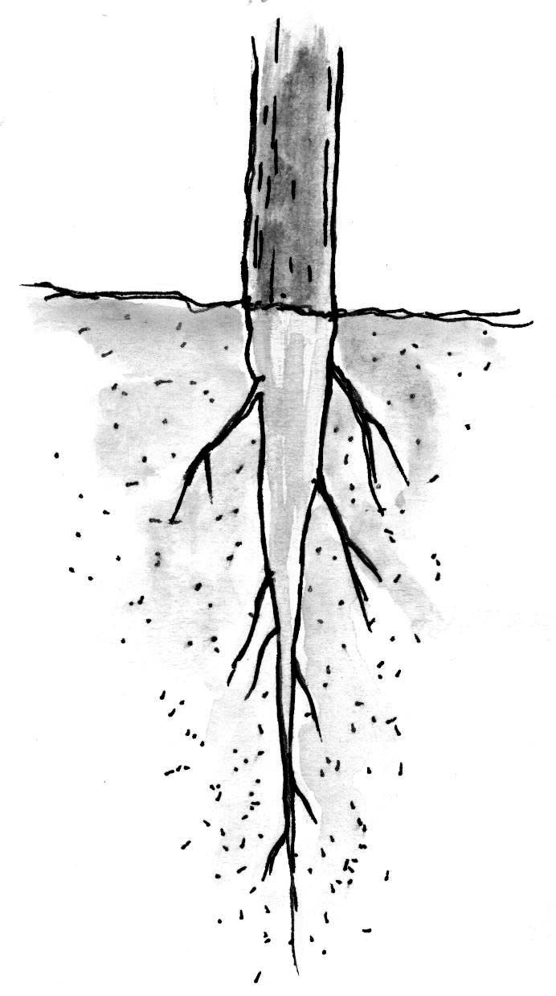
tap root
- Tap roots are found on plant likes beans, peas, Soya beans, coffee, tea, cocoa, mvule, musizi, mahogany.
- Fibrous root system.
These are very many roots growing and farming the root system of the plant. there is no main root and all of them are the same.

Fibrous roots are found on plants like maize, sorghum, millet, rice, wheat and grass.
- Prop roots.
These are roots which grow form the stems of plants. They grow in order to give extra support to the plant. They are known as adventitious roots or secondary roots.

- Prop roots are found on plants like maize, millet, sorghum, rice etc
Evaluation exercise
  - What part on roots:
- Sucks water and mineral salts from the soil?
- Protects a young growing root?
  - Name two plants with tap roots.
  - Write down two functions of roots to plants.
The diagram shows a type of root.

4. Which of these plants has the above root system?
(maize, onion, bean, pineapple)
5. Name the part of the plant which is eaten by man on the following crops;
(a) Cassava plant _________________________
(b) Onions _________________________
(c) Mangoes _________________________
(d) Simsim _________________________

Functions of roots to a plant
- Roots hold the plant firmly in the soil.
- Roots absorb/suck water and dissolved mineral salts from the soil for the plant
- Some roots store food for the plant e.g. cassava, sweet potatoes, carrots etc
Uses of roots to animals and people
- Some roots are used as food
- Some roots are used to make medicine
- Some roots are used for decoration
- Roots fix the plant firmly in the soil
- Roots suck water and mineral salts from the soil
Types of roots include

- tap roots system
- fibrous roots system
- adventitious roots
- prop roots

Evaluation Exercise
- Write down any four uses of roots to people.
- What are the two main systems which make up a flowering plant?
- What are the three main parts which make up a flowering plant?
- Write down four parts which are found on the shoot system.
- Write down two parts which are found on the root system.

SUB – THEME: Flowers
What is a flower?
A flower is a part on a plant which produces seeds.
- The external parts of a flower are: -
The petals, sepals and flower stalk
- The internal structures of a flower
Parts of a flower
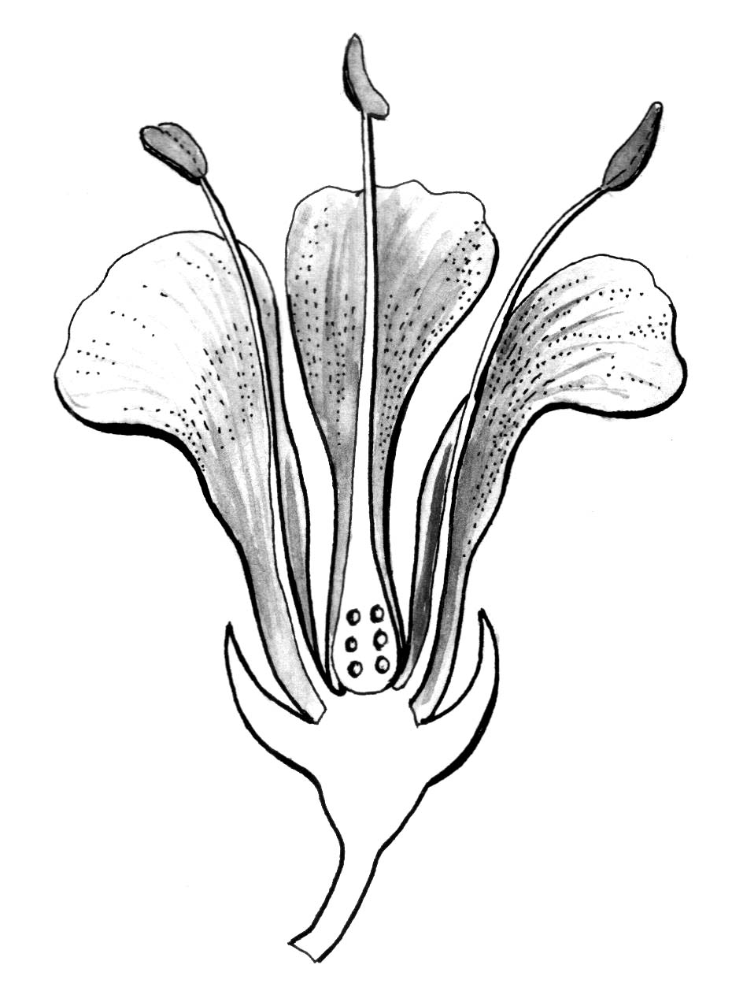
stigma
sepals
petals
ovules
filament
flower stalk
receptacle
Ovary
style
anther

Functions of each part
Petals: Attract insects for pollination
Anthers: Produce pollen grains
Filament: It holds the anthers in position
Stigma: It receives pollen grains
Style: It keeps the stigma upright.
Ovary: It keeps the ovules and develops into a fruit.
Ovules: They develop into seeds after fertilization
Sepals: These protect the flower when it is still young
Flower stalk: It holds the flower in an upright position.
The pistil
The pistil is the female part of a flower. it is made up of three parts.
The stigma – The style – The ovary
The stamen:
The stamen is the male part of a flower. It is made up of two parts

Anthers and the filament
pistil stamen
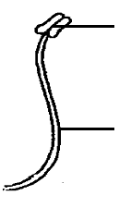
anther
filament
stigma
ovary
style
Evaluation Exercise
  - What is a flower?
  - Name the three external parts of a flower.
  - Name any four internal parts of a flower.
  - What is a pistil?
  - Mention the function of the following parts in a flower.

- petals
- stigma
- ovules

SUB – THEME: Uses of flowers
- They are used for decoration on various functions like wedding and parties
- They are used to get perfumes
- They are used to make insecticides
- Farmers grow and sell them to get money.
- Flowers produce seeds to continue the life of plants
- Flowers produce a sweet juice called nectar which bees use to make honey.
How to conserve and protect plants
- When one cuts down a tree should plant five.
- Some plants are looked after in botanical gardens like in Entebbe.
- The government should enforce laws against cutting down of trees.
- Electricity should reach every part of the country because it is used for cooking instead of firewood.
- Trees in forests should be cut carefully.

Evaluation exercise
- Write down four uses of flowers.
- What name is give to the sweet juice made by flowers?
- Write down three ways how to protect plants.
4. Write True or False about bees.
(a) A bee is an example of true insects. _________________
(b) Bees defend themselves by biting their enemies. _____________
(c) Bees visit flowers to carry out pollination. _______________
(d) Bees live in hives. ___________________
5. What do bees collect from flowers?

Subtheme: Seeds
A seed is a fertilized ovule
A seed develops into a new plant
Seeds are classified into two groups namely;
- Monocotyledonous
- Dicotyledonous
Examples of monocotyledonous seeds
maize, millet, sorghum, wheat, barley, rice
Examples of Dicotyledonous seeds
beans, groundnuts, soya bens
Seed germination
Seed germination is the process by which a seed embryo develops into a seedling
There are three conditions necessary
- oxygen
- water
- suitable temperature
Types of germination
- Epigeal germination
This is where the cotyledon comes out of the ground. It’s common in dicots e.g. legumes (beans, g. nuts etc)
- Hypogeal germination
This is where the cotyledon remains in the ground (it’s common in cereals or monocots like rice, maize, barley etc)
Hypogeal germination
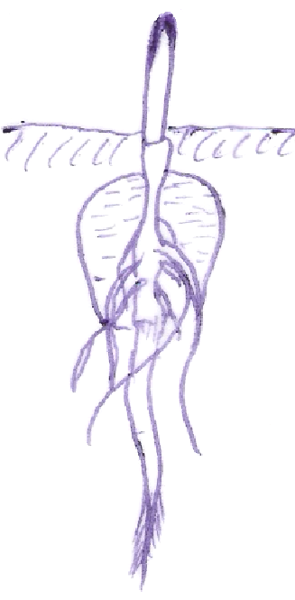

Epigeal germinaiton
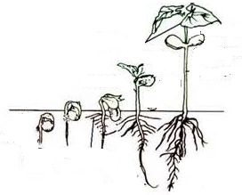
Evaluation exercise
  - Circle the odd man out
maize, beans, rice, millet,
  - In which group of seeds do these crops belong?
- Maize, rice millet , sorghum____________________
b) cowpeas, beans, groundnuts __________________
3. Underline the condition that is NOT needed by a seed to germinate.
Oxygen moisture wind sunlight
4. Define the following terms
Epigeal germination
Hypogeal germination
5. Give two examples of plants which undergo the epigeal type of germination
6. Give two examples of plants which undergo the hypogeal type of germination
7. Name the part labeled D in the diagram below
cotyledon

Importance of plants to animals
- -Plants provide food to animals.
- Plants provide shelter to animals.
- Plants provide medicine to animals.
- Plants provide oxygen to animals
SUB – THEME: Crop growing practices
Crops need good soil to grow well. However, when the same plant is grown on the same land many times, it does not grow well. Therefore we must change and plant other crops.
The growing of different types of crops on the same piece of land at different times is called crop rotation.
A school garden is very useful to school children because: -
- Children learn how to dig
- Children learn about crops and how to grow them.
- Children get food to eat.
- The school gets money after selling the excess food.
Points to consider when planning a school garden
- You should have garden tools.
- You should have enough money. (capital)
- You should have enough seeds.
A good site for a garden
The site or a place to start a garden should be carefully selected.
- It should be near the homes or school.
- It should be near a water source.
- It should not be too far from the road.
- The place should not be too sloppy.
- It should have enough sunlight and not in the shade of trees or buildings.
- It should not be too close a very dusty road.

Evaluation exercise
- Give three reasons why a school garden is important
- Write down three points to consider when planning a school garden.
- What do we call the growing different crops on the same piece of land season after season?
- Mention any four things we should be look fro when choosing a site for a garden.

SUB – THEME: Preparing the garden
Steps to follow after choosing a good site for the garden
- Clear the bush by slashing.
- Digging – Dig the cleared land.
- Ploughing – Put some manure in the soil.
- Prepare holes or small furrows for planting crops
- Fence the prepared plot.
- Wait for the rains
A good garden should have: -
- A nursery bed
- A record chart.
- A demonstration garden
A nursery bed is a place where seeds are first planted before taking them to a well prepared garden as seedlings
Uses of a nursery bed
- It gives shelter to the seedling
- It is easy to select seedlings before transplanting
- It is easy to care for the seedlings
- Water enters the soil properly
Transplanting
This is the transfer of seedlings from a nursery bed to a well prepared garden
- The best time to transplant seedlings is in the evening when the sun has set because there is a low rate of transpiration.
A seedling is a young plant
Evaluation exercise
  - Mention any three steps that must be taken or followed when preparing the land to be ready for planting crops.
  - What name is given to a place where seeds are first planted?
  - Write down the uses of a nursery bed.
  - Write a sentence using each of the following words
    - Transplanting
    - Crop rotation
    - seedling
  - What is the best time for transferring seedlings?

SUB – THEME: GROUPS OF CROPS
Before planting selecting seeds or seedlings is very important
There are two methods of planting that is row planting and Broadcasting
There are five different crops that can be grown on a school garden
- Cereals.
These are crops which produce seeds called grains. e.g. sorghum, millet, rice, wheat and maize.
- Fruits
These are crops which produce fruits which are eaten when ripe and we can get juice from them. They include: - Apples, oranges, mangoes, paw paws, pineapple etc
- Vegetables:
These are crops we eat the leaves. They are also called green e.g. cabbages, spinach, lettuce, dodo, nakati, sukuma wiki, etc
- Root crops
These are crops we eat swollen roots. They include cassava, sweet potatoes and carrots.
- Legume crops:
These are crops which have root nodules on their roots and they keep their seeds in pods. A root nodule is small swelling on the root. Examples include beans, peas, groundnuts, Soya beans.

A root of a legume
Root nodules
Crop rotation is the growing of different types of crops on the same piece of land seasonally.
Importance of crop rotation
- Controls soil erosion
- Maintains soil fertility
- Controls crop pests and diseases
- Keeps moisture in the soil

Evaluation exercise
- Give two examples of the following crops.

- cereals
- fruits
- vegetable crops
- legumes

- What are legumes?
- What is seed germination?
- Write down the three conditions necessary for seed germination to take place.

SUB – THEME: Garden tools
Each garden tool is made for a particular use. Some common garden tools and their uses.
1. A panga  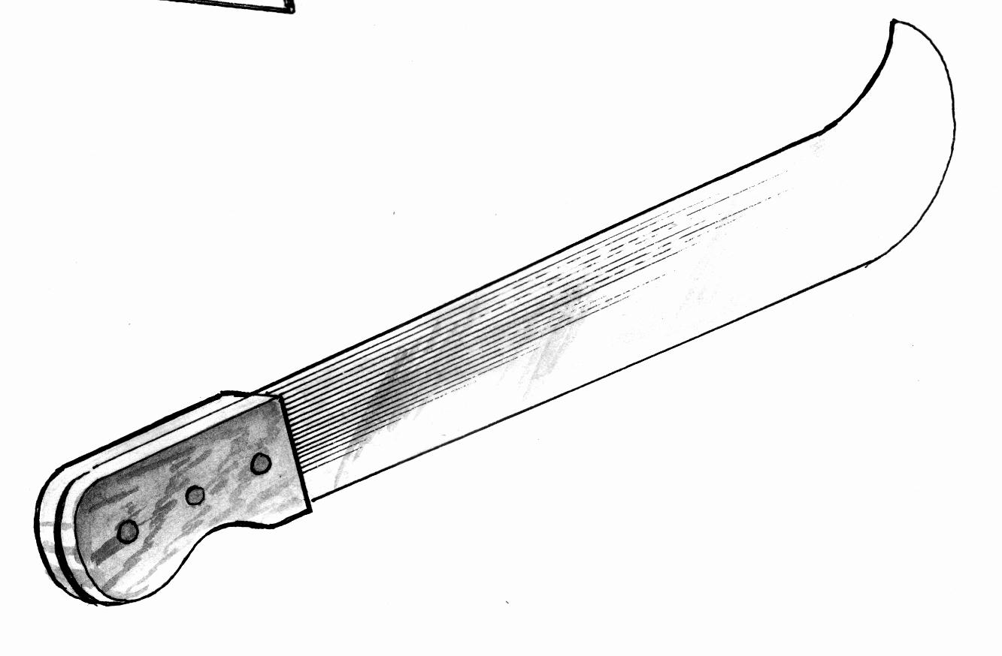 | Used for clearing bush, cutting wood and removing branches
2. A hoe  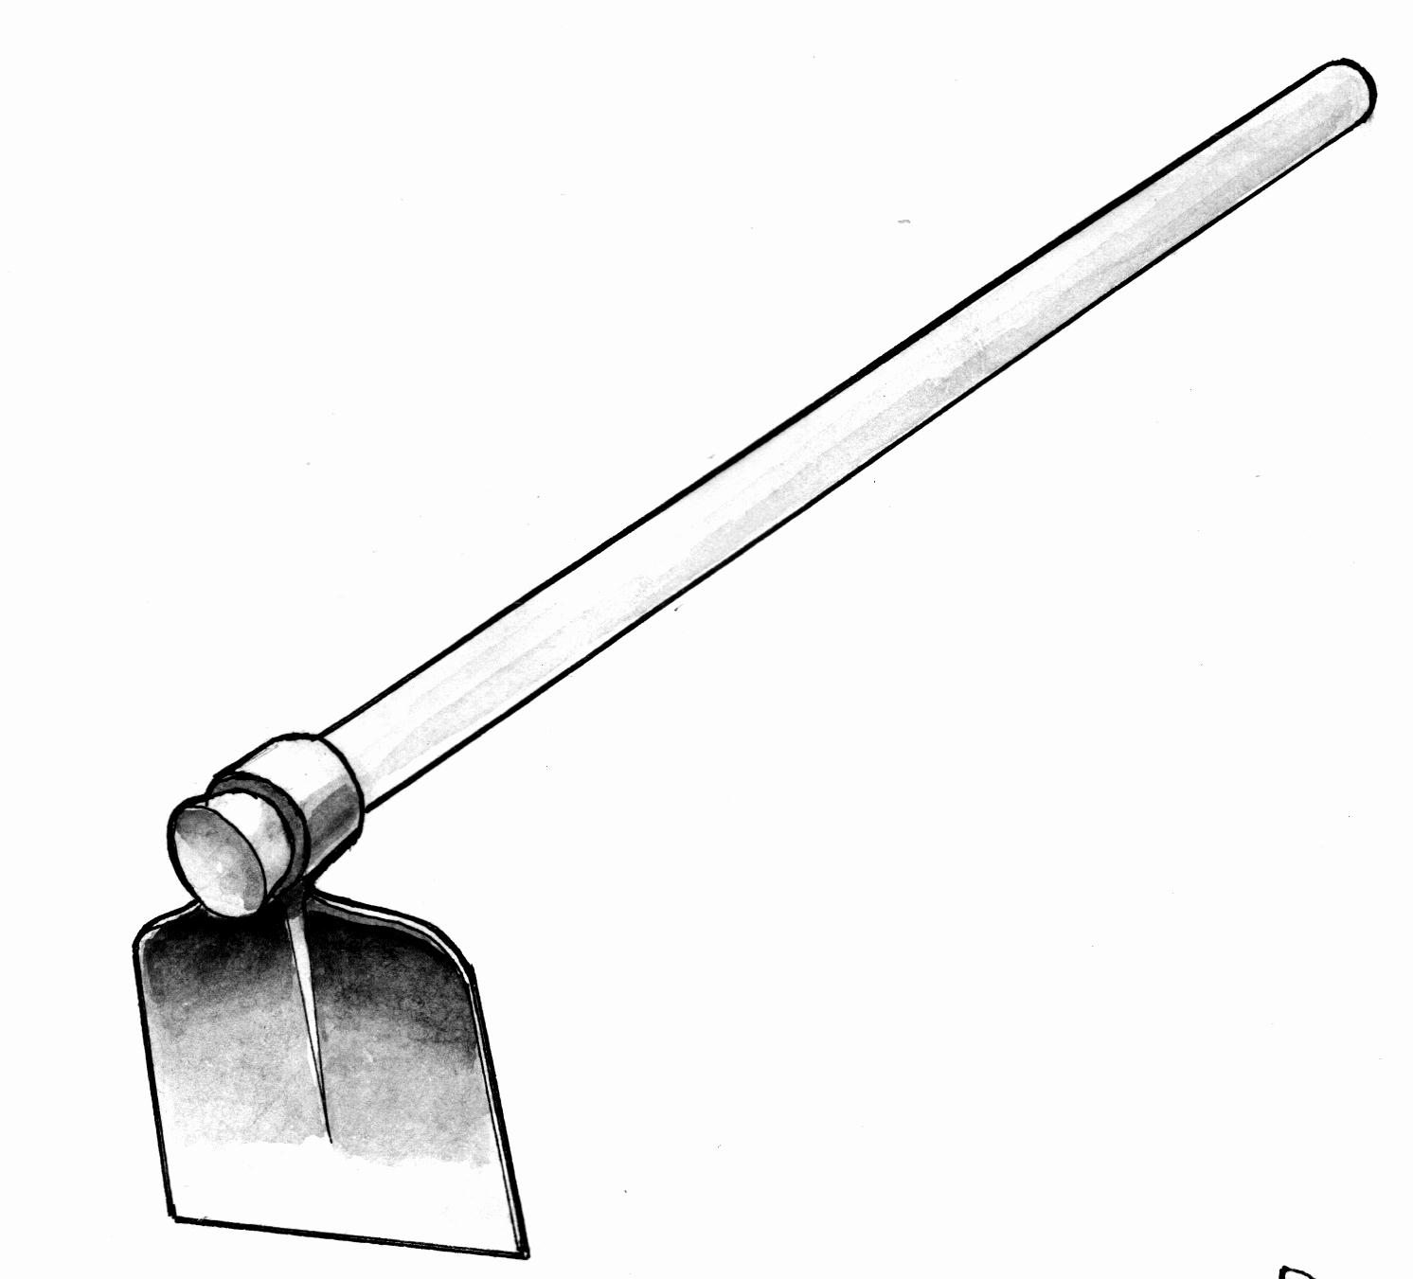 | Used for weeding, digging and planting
3. A forked hoe  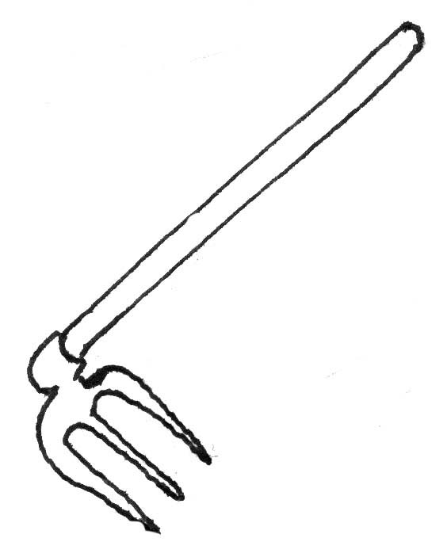 | Digging stony hard soils removing roots and stones in a garden
4. A rake  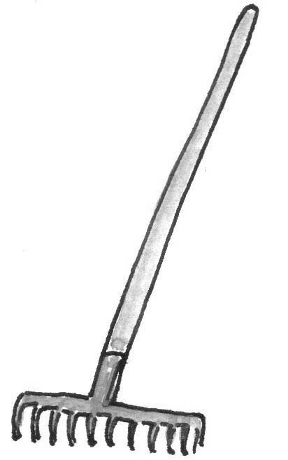 | Levelling soil, collecting dry weeds, removing dead leaves and spreading manure
5. A trowel  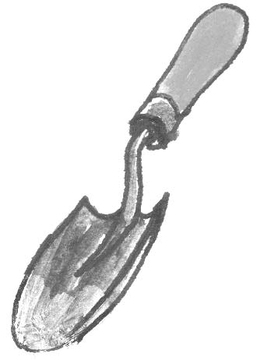 | Transplanting seedlings
6. A sickle  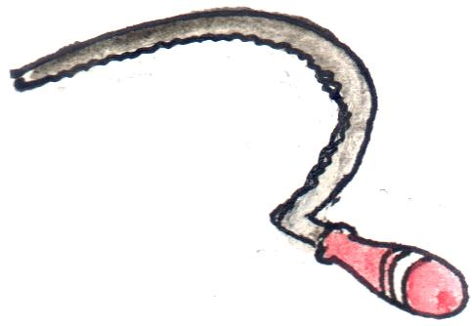 | Harvesting rice, wheat, and cutting weeds
7. A garden fork  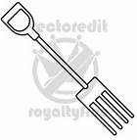 | Lifting manure, turning compost pit
8. An axe  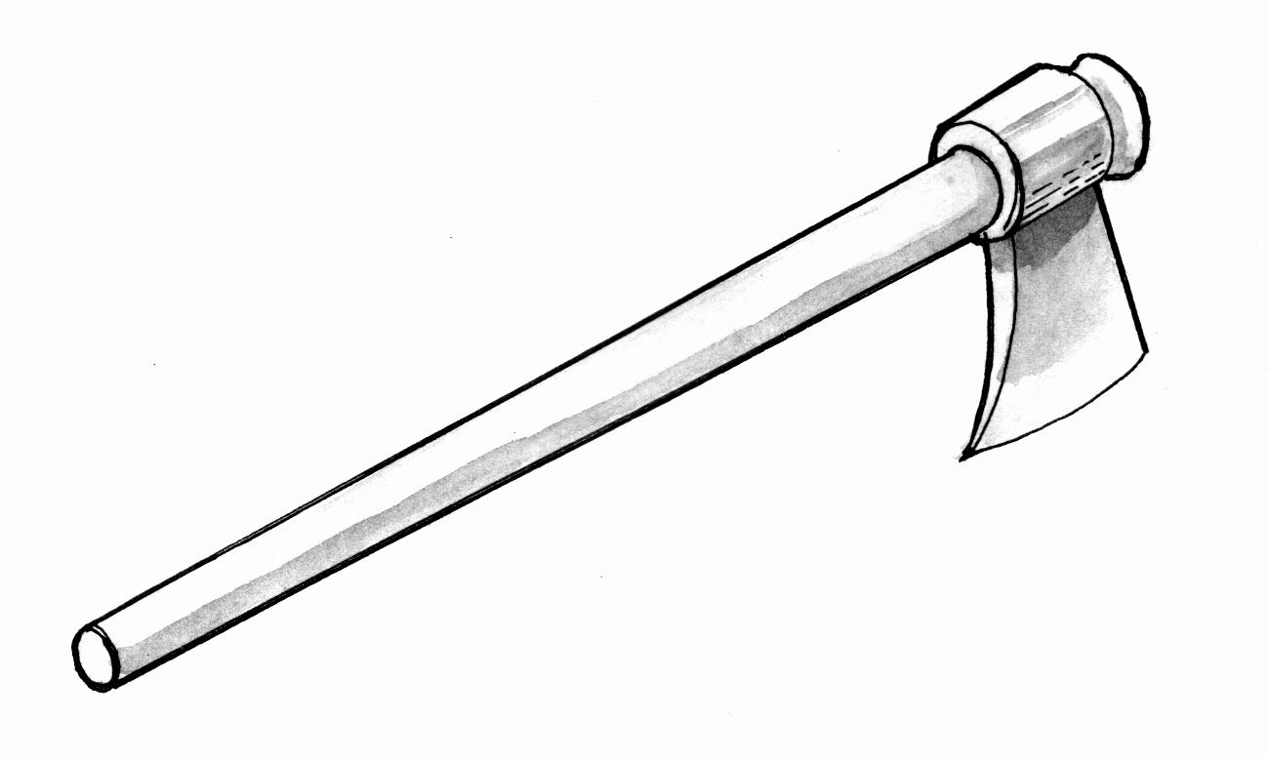 | Felling big trees splitting timber, cutting firewood
9. Spade  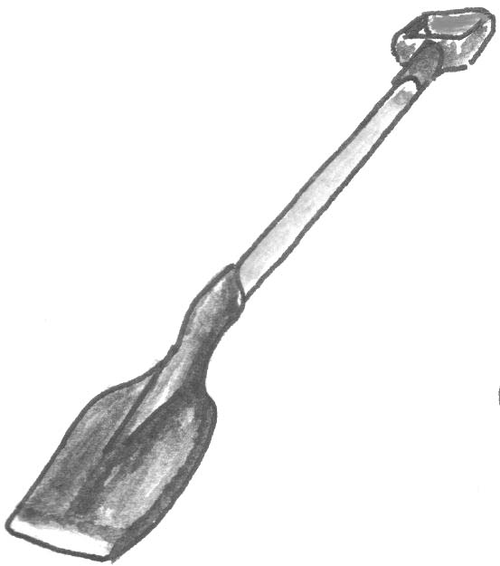 | Moving loose soil , moving manure
10. Watering can  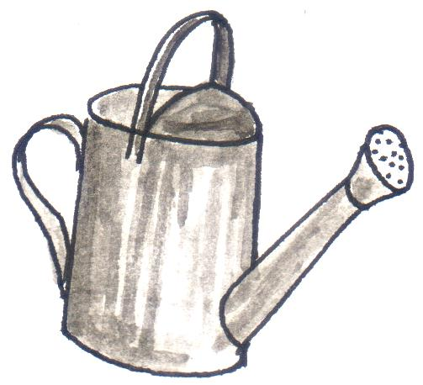 | Watering or irrigating by hands
Evaluation exercise
  - Draw the garden tool and write its use.

- A panga
- A slasher
- A rake

- A garden fork
- A wheel barrow

2 Name the garden tool which a farmer uses for;
i) transplanting seedlings _____________________________________________
ii) watering his crops ________________________________________________

SUB – THEME: Common crop pests and disease
What is a pest?
Pests are birds, animals or insects which destroy our plants.
- pests and diseases damage our crops
- Pests and diseases reduce the amount of food to be harvested.
- Pests and disease make the plant to look unhealthy
- Some pests eat leaves, stems and roots
Examples of crop pests
Rats, bean weevils, grass hoppers, eel worms, aphids, maize stalk borers, weaverbirds, cut worms, monkeys, sweet potato weevil, mealy bug, cotton strainer etc
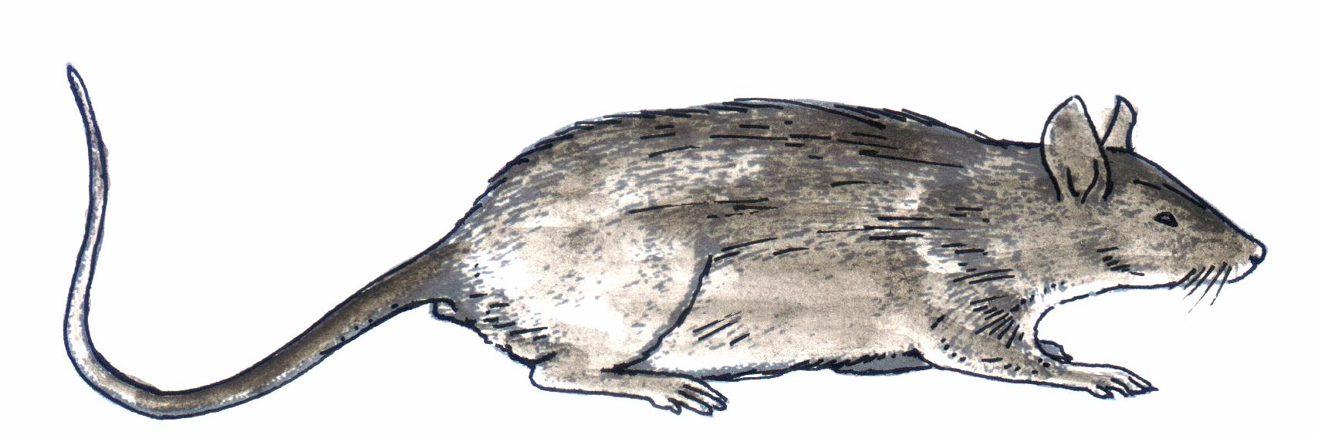
Rat locust

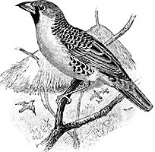

weaver bird

Examples of crop disease cassava mosaic, bean rust, bacterial wilt, white leaf right, tobacco mosaic etc.

Evaluation exercise
  - What is a pest?
  - Mention five examples of pests.
  - Write down four examples of crop diseases.
  - State any two dangers of pests and diseases.

Ways of controlling pests from the garden
- By spraying the crops using a special type of chemical called pesticides
- By putting scare crows in the garden to scare of animals like birds, monkey
- By practicing crop rotation
- By planting early before the pests multiply

